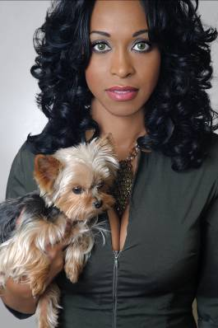

Saphonia!
Aesthetics Coach Saphonia Gee has been published in Skin Inc., New Beauty, DaySpa Magazine, and other beauty publications. She is an expert in the field of beauty, and travels extensively as an industry educator and spokesperson.
Trained as a Certified Aesthetician and nursing assistant, Saphonia is president and CEO of the Virginia Institute of Esthetics (VIE), and founder of the Society of Virginia Skincare Specialists. At VIE, she developed an educational program for an Associate's Degree of Esthetics. Together with her team of master estheticians, Saphonia provides high-quality skin care protocols and products for her patients.
She crafted and successfully lobbied for the passage of House Bill 2510, requiring estheticians in Virginia to be licensed. Her expertise earned Saphonia an appointment by the governor to the State Board of Barbers and Cosmetologists.
Along with her certifications in Paramedical Esthetics and Nursing Assistance, Saphonia holds licenses for Makeup Artistry, Braiding, and Wax Instruction, and is an international diplomat for Comite International d’Esthetique et de Cosmetologie (CIDESCO).
She is a board member of ForKids, a non-profit organization dedicated to helping homeless families in South Hampton Roads.
****

Call Saphonia at (757) 582-5827 to schedule your personal beauty assessment and learn valuable self-investment skills.

